Battle of Best Businesses in Brisbane Burbs

Finding the most suitable suburb in Brisbane for a new business venture

Joakim Arvidsson
May 29, 2020

1. Introduction

1.1 Background

Brisbane is the most populous city, with over 2.5 million residents, and the capital of the Australian state of Queensland. It is the third most populous city in Australia after Sydney and Melbourne.

The city is divided up into 6 settlements, each with their own suburbs. The 6 settlements are:

- Inner suburbs
- Northern suburbs
- Southern suburbs
- Eastern suburbs
- Western suburbs
- Moreton Bay

Together, these 6 settlements have a total of 196 suburbs, each with different types of already established businesses.

1.2 Business Problem

More and more people are moving to Brisbane from more expensive cities such as Sydney and Melbourne, so the city is growing due to this migration. For someone who is looking to move to Brisbane (or has already moved here, like we have), and is looking to start a new local business venture, it may be difficult to know what type of business would be most likely to succeed.

While there are many already established businesses in Brisbane, there are many that don’t exist in all suburbs, even though there might be a demand for products or services of that business. This report attempts to provide guidance as to what type of business might be suitable in certain suburbs of Brisbane.

1.3 Target Audience

Anyone who is looking to start a new business in any of the suburbs of Brisbane, Australia.

2. Data Sourcing and Cleaning

2.1 Data Sources

The first set of data contains the names of each suburb in Brisbane, the post code, the Local Government Area (LGA), and the geospatial coordinates (longitude and latitude) of each suburb. This set of data is scraped using BeutifulSoup from the URL: https://www.geonames.org/postal-codes/AU/QLD/queensland.html. The data is also cleaned and formatted into a pandas data-frame, so it can be used with the second set of data in order to find insight.

The second set of data is from Foursquare, which contains location data such as venue name and venue category, based on the geospatial coordinates of the suburbs. The Foursquare API is used to retrieve this data, using a free Foursquare developer account, which can be created here: https://developer.foursquare.com/.
The two data-sets are then explored and analyzed together to find insight to the data. For example, the top 5 most frequent type of venue per suburb is found, as well as clusters of venue types using the k-means algorithm.

2.2 Data Cleaning

The first set of data, with Brisbane suburb names, postal codes, LGA, and location coordinates (longitude and latitude) was scraped from the above website using BeautifulSoup. However, when loaded into a Pandas dataframe, the latitude and longitude values ended up on a separate row on their own (see below).

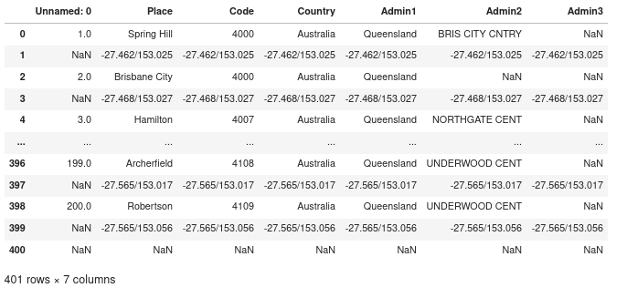

This required a bit of cleanup, including renaming of some columns, as well as removal of unnecessary columns, in order to end up with a clean dataframe of all the required data:

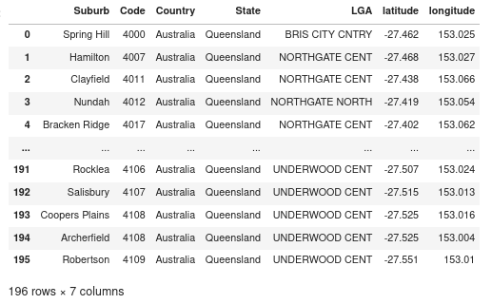

The second set of data was retrieved from the Foursquare API and required a bit of data cleaning as well. The data retrieved in it’s raw JSON file format looked like this:

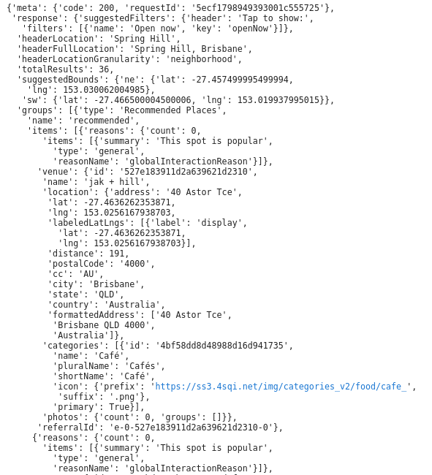

This also had to be cleaned up and loaded into a Pandas data-frame for further analysis and processing.

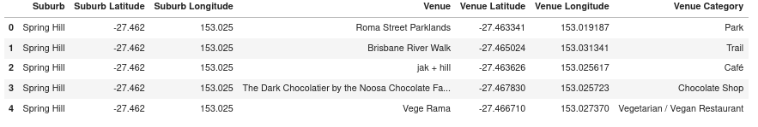

3. Methodology

3.1 Exploratory Data Analysis

Now that we have the required data cleaned and in a nice pandas dataframe format, let's do some Exploratory Data Analysis (EDA).

By running the .unique() method on the ‘Venue Category’ column of the dataframe, we find that there are 267 unique types of venues in the dataset.

Also by iterating on the venues in each suburb, we find that many suburbs have over a 100 venues in a radius of 500 meters.

Furthermore, if we convert the different venue types to binary values, using one-hot encoding, we can first rank the categories in each suburb by frequency, as well as using a Machine Learning algorithm, such as K-Means, to find further insight into the data. For example, the most frequent venues in the suburb where I live (Everton Park) are:

----Everton Park----
venue freq
0 Asian Restaurant 0.5
1 Construction & Landscaping 0.5
2 American Restaurant 0.0
3 Park 0.0
4 Movie Theater 0.0

We can also group the top 10 most frequent venues for each suburb into a single dataframe. The below table has the first and last 5 entries in such a dataframe:

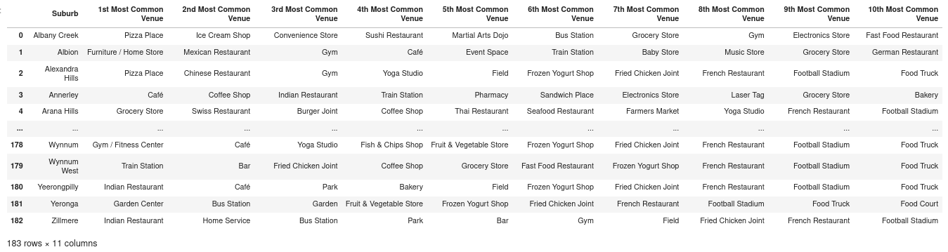

3.2 Clustering Venues

If we convert the different venue types to binary values, using one-hot encoding, we can first rank the categories in each suburb by frequency, as well as using a Machine Learning algorithm, such as K-Means, to find further insight into the data.

The below map shows the different clusters of suburbs with similar venues in Brisbane.

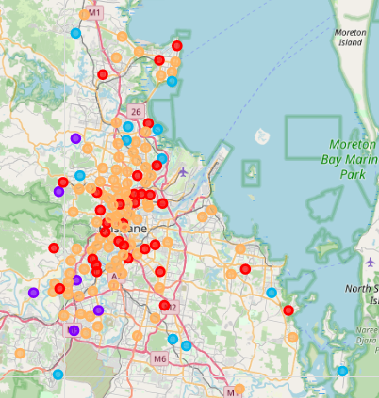

As can be seen on the map, the first and last cluster is more common in the center of Brisbane, whereas the other clusters are more common in the surrounding suburbs.

3.3 Examining Venues in Each Cluster

If we look at the most common venue categories in each cluster, we find that the first cluster has mostly cafes/coffee shops and restaurants. The second cluster contains mostly Bus stations or other public venues such as parks or stadiums. The third cluster also contains mostly Parks, Playgrounds, or stores. The fourth cluster contains only a single venue, Basketball Court. And the fifth and final cluster contains family oriented venues such as kids stores, pools, and family restaurants.

3.4 Exploring a Specific Suburb

Let's explore a specific suburb to see what type of businesses are most/least common in it. We live in the Everton Park suburb, so let's look more closely at this one.

In Everton Park we find that there are only two venues in the Foursquare database:

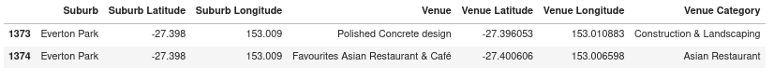
A person starting a new business in Brisbane might be more likely to start a restaurant, so let’s see how many restaurants there are within a radius of 2 km from the above Asian restaurant in Everton Park.

As can be seen in the below table, there are a number of other restaurants within a radius of 2 km, most of them being fast food restaurants, cafes, grocery stores, or coffee shops.
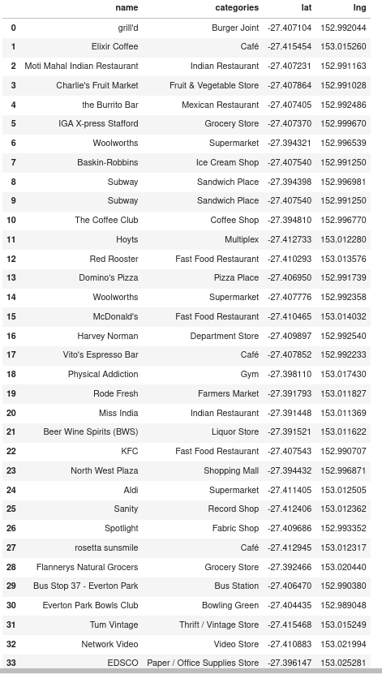

4. Results

4.1 Discussion of Results

As can be seen in the above list of venues within 2 km of the restaurant in Everton Park, there are 36 venues returned by FourSquare. While there are several fast food restaurants, and a number of Cafes/coffee shops and Indian restaurants, there are no Thai food restaurants or Italian food restaurants (not counting Domino's Pizza as Italian). Therefore, an entrepreneur looking to start a new restaurant in the area might look at starting a new Thai food or Italian food restaurant, as the area currently doesn't have either of those restaurants.

5. Discussion

5.1 Observations

We found that the venues in the suburbs of Brisbane could be grouped into 5 different clusters, namely:

- Cafes/Coffee shops and restaurants
- Public transport venues
- Parks, Playgrounds, Stores
- Sport venues
- Family oriented venues

We also found that in Everton Park, there are several fastfood restaurants, as well as cafes and Indian restaurants, there are no Thai food or Italian restaurants, so starting a new Thai food or Italian restaurant might be something worth while investigating further.

5.2 Recommendations

For anyone looking to open a cafe or coffee shop, they might want to look at suburbs outside of the first cluster, as these suburbs already have plenty of coffee shops.

Furthermore, anyone looking to start a new restaurant in the Everton Park suburb, it’s recommended to look at restaurants that are currently not present within a reasonable radius (such as 2 km), such as a Thai Food restaurant or an Italian Food restaurant.

6. Conclusion

This report offers insight to potential business entrepreneurs in the Brisbane area. The report finds what type of current business venues exist in a certain suburb. This is helpful in determining what type of business might be successful in a certain suburb. For example, we found that in Everton Park, there are several fast food restaurants, as well as cafes and Indian restaurants, there are no Thai food or Italian restaurants, so starting a new Thai food or Italian restaurant might be something worth while investigating further.

